Your Paper's Title Starts Here (Arial, 16 points)
Thomas Edison^{1, a}, First-name Family-name^{1,b} , First-name Family-name^{2,c} and Others(Arial, 14 points)^{3,d, *}
¹Faculty of Technology, World University, 1-5-1 Academic village, Innovation City 777-7777, Japan (Arial, 11 points)
²Faculty/School/Division, Institution, Postal address of the co-author including country
³List the addresses of all the authors in the same way
* Corresponding author
ª<e-mail address>, ^{b}<e-mail address>, ^{c}<e-mail address>, ^{d}<e-mail address>
Keywords: journal, format, instructions to authors, reproducing kernels, support vector machine (Arial, 11 points. Max 5 words, all small letters)
For the rest of the paper, please use Times Roman (Times New Roman, 12 points) in text.

Abstract. This document explains and demonstrates how to prepare your camera-ready manuscript for proceedings of ICTSS2023. Please copy your text without format to this template. The abstract should consist of one paragraph of about 150 words. The abstract should present a concise statement of the scope, principal findings, and conclusions of the paper. Abstracts cannot include lists, tables, figures, equations, footnotes, or references.

1. Introduction
With an aim to ensure that all contributions published in this journal have a uniform appearance, authors are kindly asked to generate a PDF document that meets the formatting specifications outlined in this document. The paper should be prepared in Microsoft Word. General specifications, including margins, fonts, citation styles, and figure placement are outlined in following sections.
This document provides a template and guidelines for authors using MS-Word ONLY to prepare a paper/manuscript for this journal. Please follow the instructions carefully.
2. Organization of the Text
2.1 Section Headings, Page Numbers and Tables
The section headings are in boldface capital and lowercase letters. Second level headings are typed as part of the succeeding paragraph (like the subsection heading of this paragraph).
Page Numbers. Do not change page numbers. Leave the page numbers as this template generates.
Tables. Tables (referred with: Table 1, Table 2, ...) need to be referred in the text in the order of table number. A descriptive title should be placed above each table. Units in tables should be given in square brackets, like [m²/s].
2.2 Special Signs, Figures and Equations
Special Signs. for example , α γ μ Ω () ≥ ± ∑{10} should always be written in with the fonts Times New Roman or Arial.
Figures. The basic rules for figures are as follows,
[1] Figures (referred with: Fig. 1, Fig. 2, ...) need to be referenced in the text in the order of figure number.
[2] The caption should be self-contained and placed below the figure. If multiple sub-figures exist, each sub-figure should have sub-caption (See Fig.2).
[3] Generally, only original drawings or photographic reproductions are acceptable.
[4] Letters inside figures should be Arial font with size between 8 and 11 points. Letters inside figures should be similar size throughout the paper and they should be no smaller than 8 points and no larger than 11 points.
[5] Only good/clear photocopies are acceptable. For a good quality, the resolution of the pictures recommended to be 300 dpi (dots per inch) or higher.
[6] Utmost care must be taken to insert the figures in correct alignment with the text. There must be no big spaces of a few lines or more in the text.
[7] Please include your figures as graphic image files. Tiff format is highly recommended.
[8] In figures and tables, real numbers should have one or more digits after the decimal point.
[9] Each axis must have physical quantities and units expressed in a unified format.
[10] For a figure of photo, the minimum-necessary explanations should be written inside the photo. (See Fig.3)
[11] Screenshot of application, such as LabView, can be used only for the explanations of the functions of the application. It can NOT be used for explanations of the result/analysis of the experiment/measurement or data itself.

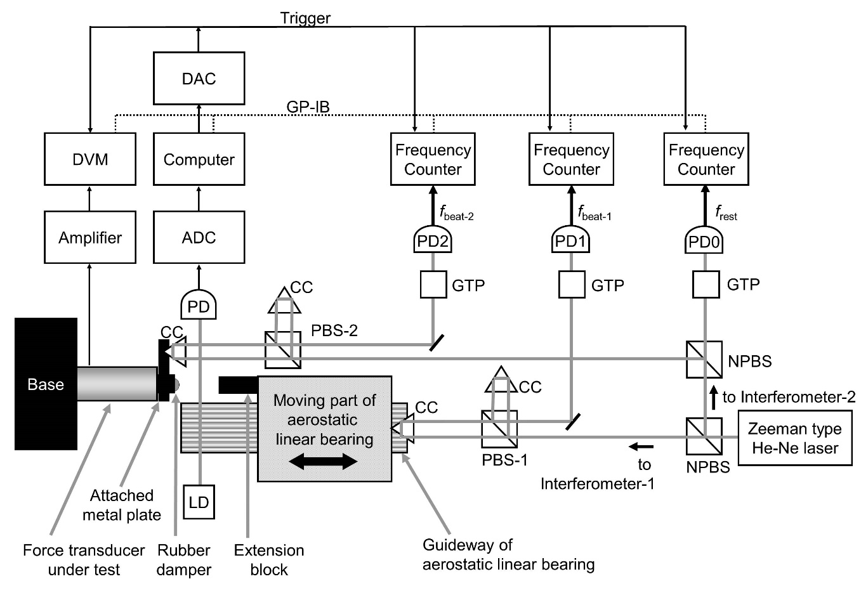
Fig. 1. Experimental Setup (Arial, 12 points). Code: CC= cube corner prism, PBS= polarizing beam splitter, NPBS= non- polarizing beam splitter, GTP= Glan-Thompson prism, PD= photo diode．Captions of figures and tables are Arial (Arial New Roman, 12 points)
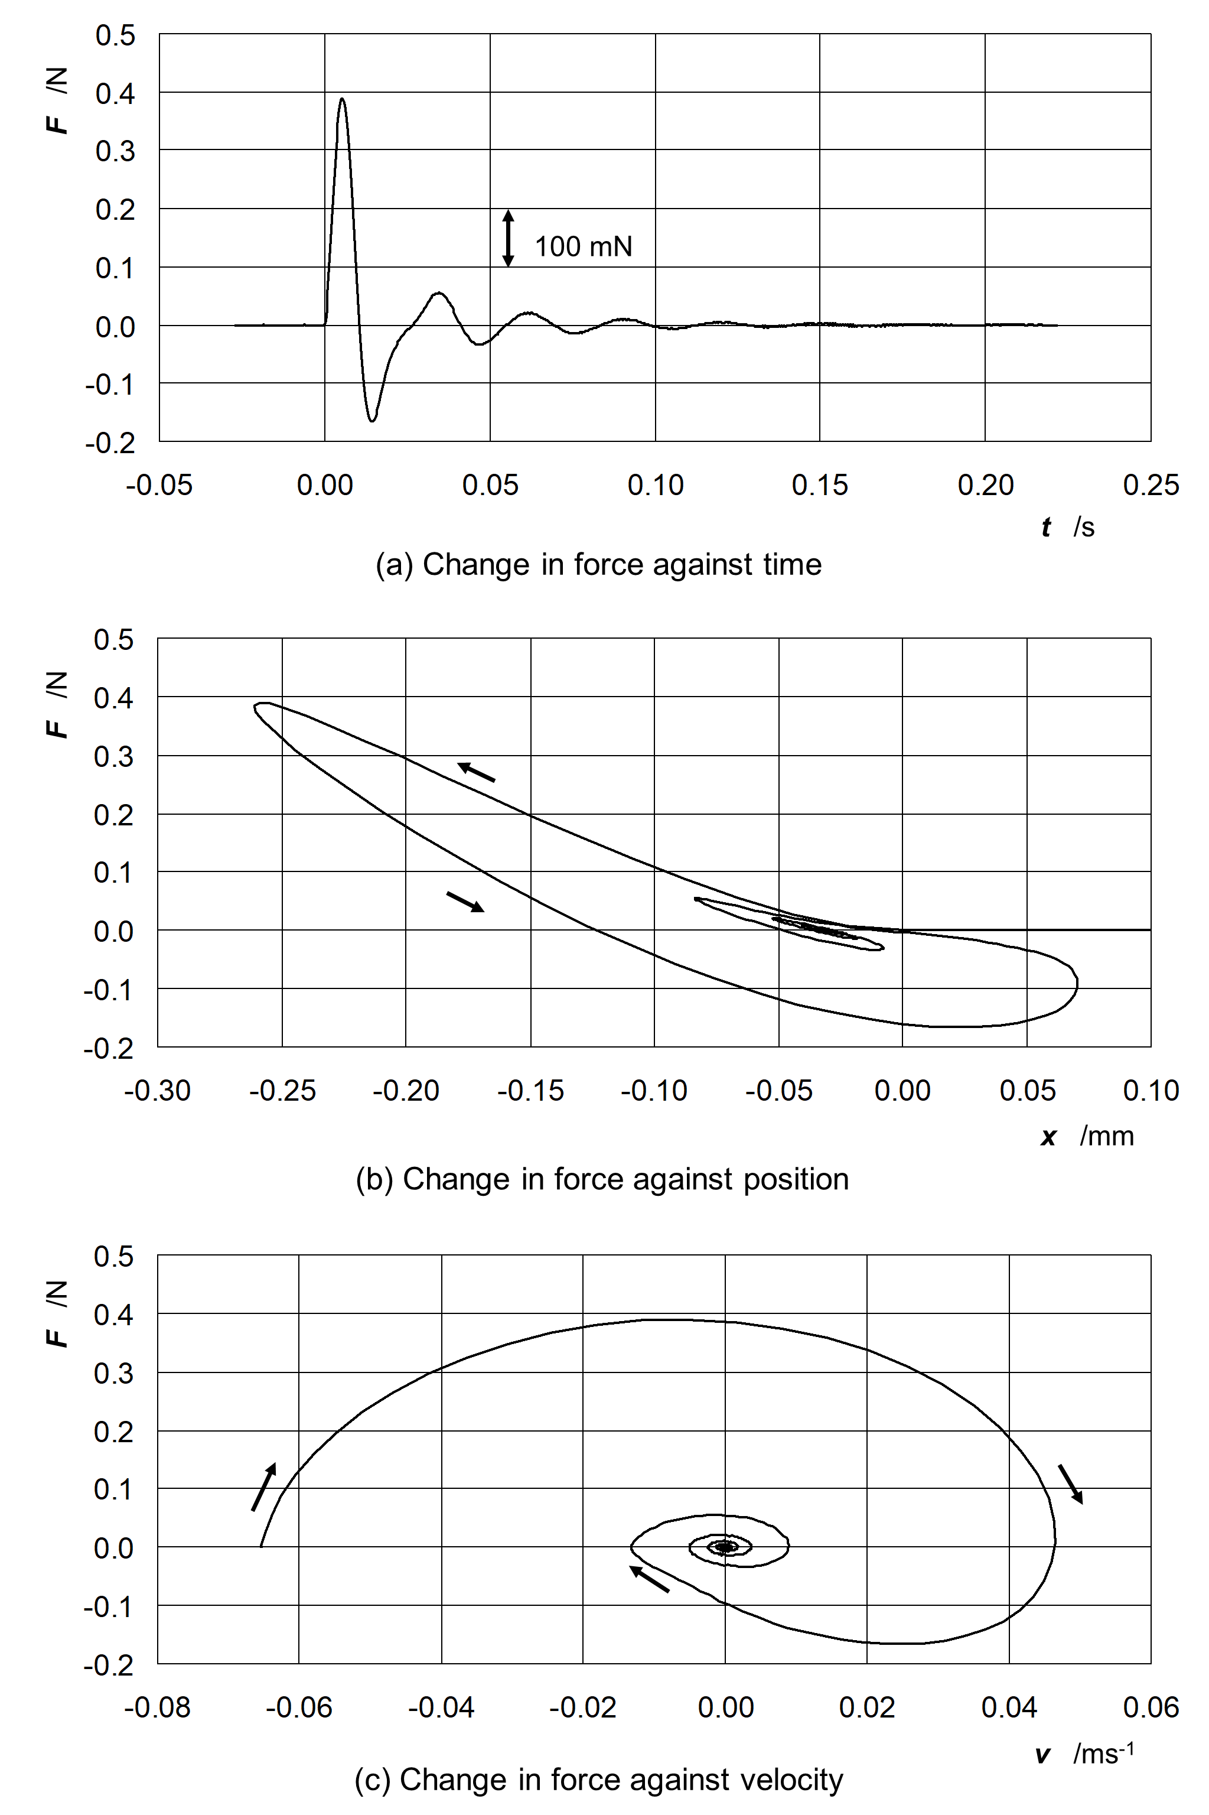
Fig. 2. Change in force against time, position and velocity
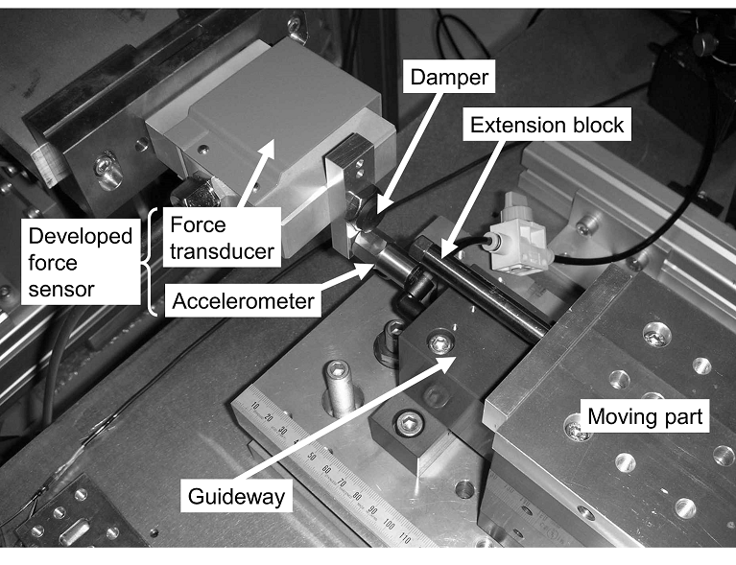
Fig. 3. Photograph around test section.

Equations. Formulas (referred with: Eq. (1), Eq. (2), …except at the beginning of a sentence: “Equation (1) is ...”) are centered and numbered consecutively. The numbers should be enclosed in parentheses and aligned right. An extra line should be placed above and below of the displayed expression.
$c^{2}=a^{2}+b^{2}$ (1)
2.3 Literature References
References are cited in the text just by square brackets [1]. Two or more references at once may be put in one set of brackets [3,4], [2-6]. The references are to be numbered in the order in which they are cited/referred in the text and are to be listed at the end of the contribution under a heading References, see our example below.
3. Conclusion
Although a conclusion may review the main points of the paper, do not replicate the abstract in the conclusion. A conclusion might elaborate on the importance of the work or suggest applications and extensions.
Acknowledgements
Acknowledgements, Appendix(s) and Reference heading should be left justified, bold, with the first letter capitalized but have no numbers. Text below continues as normal.

Appendix A
Authors including an appendix section should do so before References section. Multiple appendices should all have headings in the style used above. They will automatically be ordered A, B, C etc.
References (Add URL if available like below.)
[1] R(=first letter of first name). Araki(=family name), A. Takita, T. Ishima, H. Kawashima, N. Pornsuwancharoen, S. Punthawanunt, E. Carcasona and Y.Fujii, “Impact force measurement of a spherical body dropping onto a water surface(=title of paper)”, Review of Scientific Instruments (= name of journal, Italic & bold) , Vol. 85, No. 7, 075116, 2014. (“075116” is paper ID. No page number is available for this journal.)
https://doi.org/10.1063/1.4878629 (=URL of the paper)
[2] N. Pornsuwancharoen and P. Yupapin, “Force of optical tweezers by micro ring resonator system”, Proceedings of ICTSS2017 (Kiryu, Japan) (=city and country of conference venue) May 2017 (=month and year of conference).
[3] Nineteen Eighty-Four (=title of book), G. Orwell, Secker & Warburg (London, UK)(=name, city and country of publisher), 1949. (=year of publication)
[4] K. Maru and Y. Fujii, "Laser Doppler velocimetry technology for integration and directional discrimination"(=title of book chapter) in Optical Imaging Devices: New Technologies and Applications(=title of book), CRC Press (Boca Raton, USA) (=name, city and country of publisher), pp. 189-206, 2016
[5] Y. Fujii, N. Yoshiura, N. Ohta and A. Takita, Japanese Patent Application, No.2015-167298.
[6] Y. Fujii and N. Yoshiura, Japanese Patent, No.5757048.
[7] NPO e-JIKEI Network Promotion Institute (website), “History of NPO” (title of website if apprecable).
http://www.e-jikei.org/index_e.htm (=URL of the website)
[8] GatesNotes (=Name of Blog), “The Age of AI has begun: Artificial intelligence is as revolutionary as mobile phones and the Internet” (21 March 2023).
https://www.gatesnotes.com/The-Age-of-AI-Has-Begun (=URL of the blog)

